DATA CLEANING AND TRANSFORMATION
Project: Product Dataset Cleaning Using Microsoft Excel
1. Missing Value Handling
Explanation
Missing values are empty cells in a dataset. I identified missing values in the Price and Category columns and handled them appropriately.
- Missing Category values were filled when the product information supported a category.
- Missing Price values were kept blank because the correct prices could not be verified.
Before Cleaning
Product ID | Product Name | Brand Name | Price ($) | Quantity | Category
22-MAY-US | Backpack | North Face | 70 | 20 | Blank
07-JUN-UK | Headphones | Sony | Blank | 45 | Electroni
After Cleaning
Product ID | Product Name | Brand Name | Price ($) | Quantity | Category
22-MAY-US | Backpack | North Face | 70 | 20 | Accessories
07-JUN-UK | Headphones | Sony | Blank | 45 | Electronics
Excel formula to identify blanks:
- Price: =COUNTBLANK(D2:D35)
- Category: =COUNTBLANK(F2:F35)
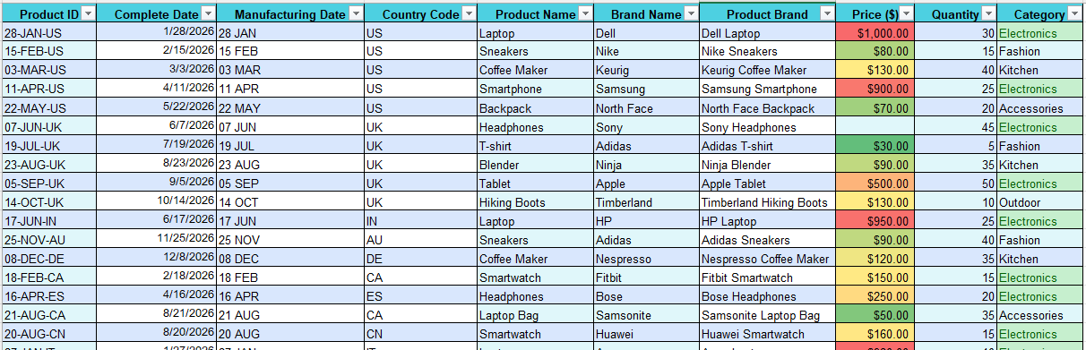
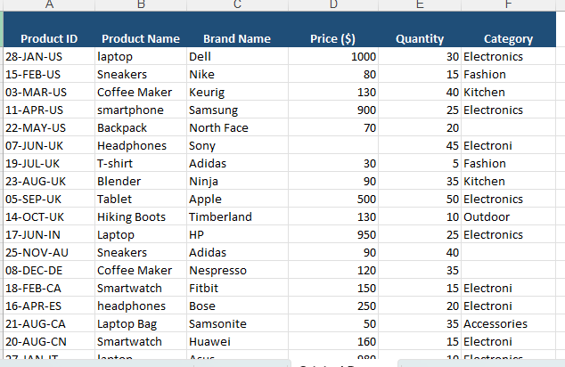

2. Find and Replace Corrections
Explanation
The dataset contained inconsistent capitalization in Product Name and a spelling mistake in Category. I used Excel's Find and Replace feature to correct these errors.
Corrections Made
Original Value | Corrected Value
laptop | Laptop
smartphone | Smartphone
headphones | Headphones
Electroni | Electronics
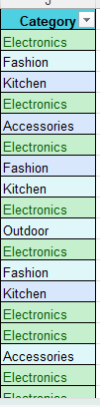
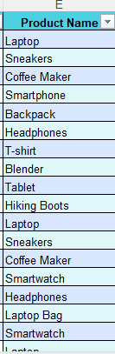
3. Duplicate Removal Process
Explanation
Duplicate records are repeated rows containing identical information. I selected all six columns and used Excel's Remove Duplicates feature to remove repeated records.
Duplicate Removal Summary
Description | Number of Records
Original records | 34
Duplicate copies removed | 03
Remaining unique records | 31

4. Column Splitting and Merging
A. Splitting Product ID
Explanation: Product ID contains date information and a country code. I separated these into two different columns.
Before Splitting
Product ID
28-JAN-US
15-FEB-US
03-MAR-US
After Splitting
Product ID | Date Component | Country Code
28-JAN-US | 28-JAN | US
15-FEB-US | 15-FEB | US
03-MAR-US | 03-MAR | US
Excel formulas:
Date Component: =LEFT(A2,6)
Country Code: =RIGHT(A2,2)
B. Merging Brand Name and Product Name
Explanation: I combined Brand Name and Product Name into a single column called Product Brand.
Before Merging
Brand Name | Product Name
Dell | Laptop
Nike | Sneakers
Samsung | Smartphone
After Merging
Product Brand
Dell Laptop
Nike Sneakers
Samsung Smartphone
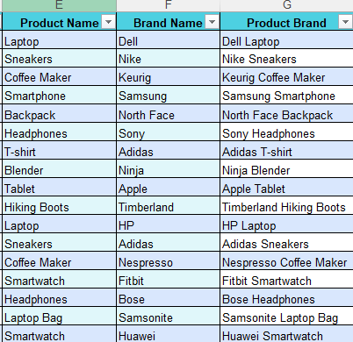
=CONCATENATE(C2," ",B2)

5. Conditional Formatting Results
Explanation
Conditional Formatting helps identify important information by changing cell appearance based on specific conditions.
I applied two types of conditional formatting.
Formatting Applied
Column | Formatting | Purpose
Price ($) | Data Bars | Compare product prices visually
Category | Green highlighting for Electronics | Identify Electronics products


